Chemical Bonding and Atomic Structure
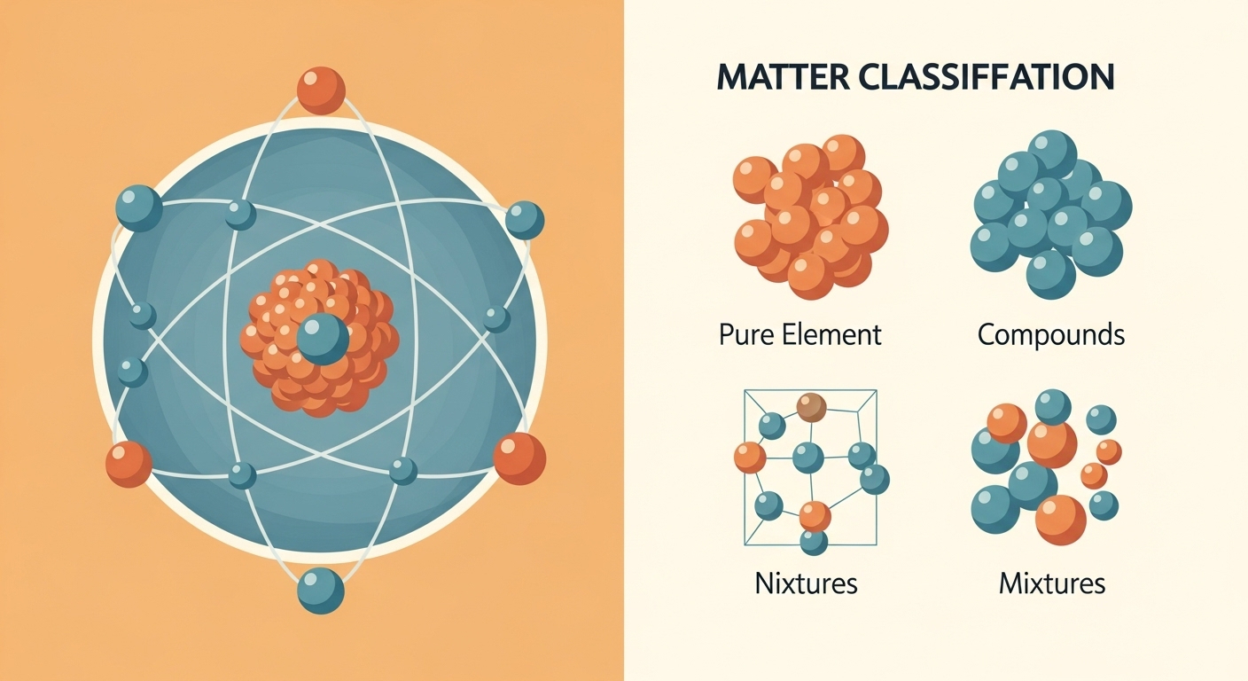

Open-Ended Questions
1. (10 Point)
The Periodic Table organizes elements based on their atomic structure. The proton number determines the identity of the atom. The number of shells and outer electrons determine an element‛s position in periods and groups.
A sodium atom has 11 protons. Explain the electronic configuration of this atom and identify its position (period and group) on the Periodic Table.

2. (10 Point)
Elements like carbon can have atoms with different masses. These atoms are called isotopes. Although their nuclei differ in neutron count, their chemical behavior remains identical in most reactions.
Define what isotopes are and explain why different isotopes of the same element show the same chemical properties.

3. (10 Point)
Ionic compounds like sodium chloride form when different types of elements react. These substances have a regular arrangement of ions called a giant lattice. Their bonding affects their physical state and properties.
Describe how an ionic bond is formed between a metal and a non-metal and explain why ionic compounds usually have high melting points.

Multiple Choice Questions

4. (5 Point)
Metals have a specific type of structure. In this structure, atoms lose their outer shell electrons. These electrons move freely throughout the whole metal sample.
Which description best explains the bonding found in a metallic lattice?

A) A sea of delocalised electrons and positive ions
B) Shared pairs of electrons between non-metal atoms
C) Different elements mixed together without bonding
D) Negative ions and positive ions in a fixed lattice
E) A nucleus containing only neutrons and protons

5. (5 Point)
Different substances conduct electricity in different ways. Some materials allow electricity to pass through them because they have particles that can move and carry a charge.
Why do metals show good electrical conductivity in the solid state?

A) The regular arrangement of atoms in a lattice
B) The presence of a sea of delocalised electrons
C) The high melting point of the metallic lattice
D) The movement of positive ions toward the negative pole
E) The strong covalent bonds between the atoms

6. (5 Point)
Metals can be hammered into thin sheets or pulled into long wires. This is possible because of the way the particles are arranged and how they react to pressure.
What allows a metal to be malleable and change shape without breaking?

A) Positive and negative ions are held in a rigid grid
B) The delocalised electrons are fixed in one place
C) There are weak intermolecular forces between layers
D) The lattice is made of different types of atoms
E) Layers of positive ions can slide over each other

True/False Questions

7. (1 Point)
Metals have a special structure. They have positive ions in a giant lattice. Electrons move freely around these ions. We call this a sea of delocalised electrons.
Metals can conduct electricity because they have a sea of delocalised electrons that can move.
☐ True ☐ False

8. (1 Point)
Metals are very strong but also flexible. You can change the shape of a metal. This is because the layers of ions can slide. The attraction between ions and electrons stays strong.
The property called malleability means that a metal is very brittle and breaks easily when you hit it.
☐ True ☐ False

Fill in the Blank Questions

9. (2 Point)
Gold and oxygen are common substances. They have only one type of atom. A substance with only one type of atom is an _______.

10. (2 Point)
Salt and sand are in a box. They are together but they are not joined. You can separate them easily. This is a _______.

